Sean Marino

Dr. Chen

CSC 4103 – Operating Systems

20 April 2017

Homework Assignment 4

1. If the OS were to know that a certain application is going to access the file data in a sequential manner, how could it exploit this information to improve performance?

If a block is accessed, the file system could transfer the subsequent blocks to wait until needed. This would cause reduced waiting time experienced by the process.

1. What are the implications of supporting UNIX consistency semantics for shared access for those files that are stored on remote file systems?

Updates are required in order for a file to become available. Supporting such a semantics for shared files on remote file systems could result in updates by a client to be immediately reported to a file server by a client and updates having to be communicated by the file server to clients caching the data immediately.

1. What are the advantages of the variation of linked allocation that uses a FAT to chain together the blocks of a file?

While accessing a block that is stored at the middle of a file, a location can be found by chasing the pointer stored in the FAT as opposed to accessing all of the file blocks separately in a sequential manner to find the pointer to the target block.

1. Suppose that disk in Exercise 12.18 rotates at 7200 RPM. What is the average rotational latency of this disk drive?

4.167 ms

1. Suppose that a disk drive has 5000 cylinders, numbered 0 to 4999. The drive is currently serving a request at cylinder 143, and the previous request was at cylinder 125. The queue of pending requests, in FIFO order, is

86, 1470, 913, 1774, 948, 1509, 1022, 1750, 130

Starting from the current head position, what is the total distance (in cylinders) that the disk arm moves to satisfy all the pending requests, for the FCFS and SSTF disk scheduling algorithms? List the order of accessed cylinders. (2 points)

FCFS:

Distance: 7081

Order: 143, 86, 1470, 913, 1774, 948, 1509, 1022, 1750, 130

SSTF:

Distance: 1745

Order: 143, 130, 86, 913, 948, 1022, 1470, 1509, 1750, 1774

1. Explain why logging metadata updates ensures recovery of a file system after a file system crash.

In the case of a system crash, the system will be able to determine all metadata updates that didn’t finish. This information will allow it to redo the updates to keep the file system in a stable state.

1. Describe three circumstances under which blocking I/O should be used. Describe three circumstances under which non-blocking I/O should be used. Why not just implement non-blocking I/O and have processes busy-wait until their device is ready?

Blocking I/O:

Appropriate when the process will only be waiting for one specific event.

Disk, Tape, Keyboard read by an application program.

Non-Blocking I/O:

Useful when I/O may come form more than one source and the order of the I/O arrival is not predetermined

Network daemons listening to more than one network socket, window managers that accept mouse movement, and I/O-management programs, such as a copy command that copies data between I/O devices.

Buffering input and output and using non-blocking I/O to have both devices occupied could optimize the program.

1. Consider a RAID Level 5 organization comprising five disks, with the parity for sets of four blocks on four disks stored on the fifth disk. Draw a diagram to illustrate the distribution of parity blocks and data blocks. How many blocks are accessed in order to perform a write of seven continuous blocks of data?

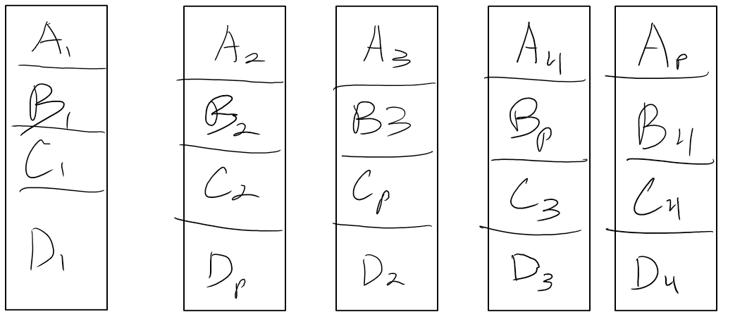

Write the seven contiguous blocks

Write the parity block of the first four blocks

Read the eight block

Compute the parity of of the next set of four blocks

Write the corresponding parity block onto the disk